|  |
| --- |
| Umbraco i/s |
| Blog 4 Umbraco |
| Usage and configuration |
|  |
| **pph, tg** |
| **12/21/2009** |

|  |
| --- |
| Goes through setting up the blog package, changing appearance and configuring advanced services like Pings, Spam filtering and Blog Roll. |

Contents

Document History 3

Introduction 4

Feature overview 5

Getting started 6

Installing 6

Configuring your blog 6

Writing your first post 7

Adding images to a blog post 7

Tagging your content 7

Change blog appearance 8

Edit the skin 8

Configuring advanced features 9

Configuring Akismet 9

Get your API key 9

Configure blog 4 umbraco 9

Setting up pinging 10

Configure blog 4 umbraco 10

Desktop blog publishing 12

Configuring the user 12

Connecting Microsoft Office Word to the blog 13

Connecting Windows Live Writer to the blog 16

# Document History

* 22/12-2009 Initial version  
  Authors: Tim Geyssens and Per Ploug Hansen

# Introduction

The blog 4 umbraco package was done as a Christmas calendar in December 2009 by Tim Geyssens, Niels Hartvig and Per Ploug Hansen.

It extend and reuses the blog package done by Tim Geyssens, which reuses alot of the work done even earlier by Niels Hartvig with the first blog package released in 2006. And includes a ton of xslt, produced by Morten Bock.

Throughout the process we received a ton of feedback and good ideas from the friendliest cms community in the world. Thank you to everyone who contributed.

# Feature overview

Included features overview

* Automatic date-based urls for blog-posts
* Gravatar support on comments
* Akismet spam filtering
* Comment moderation
* Ping services on publish
* Use skins to change appearance
* Desktop publishing support through MetaWeblog
* Tag Cloud
* Archive

# Getting started

## Installing

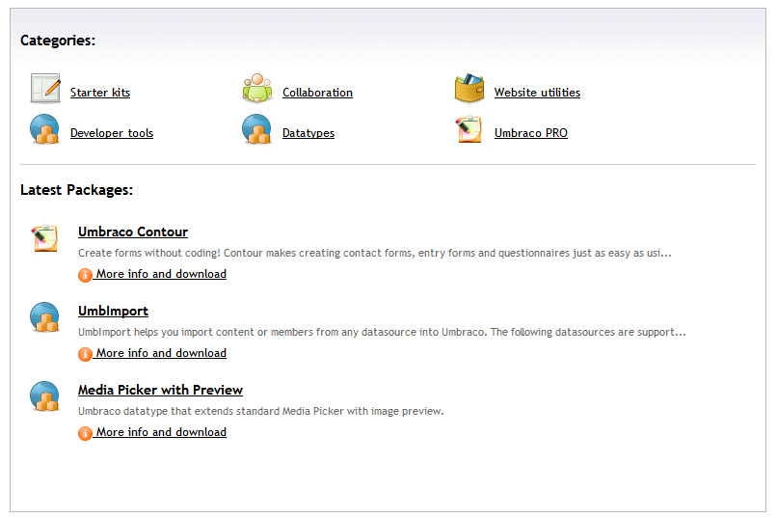To install Blog 4 Umbraco, open up your umbraco installation and go to the developer section. In the developer section you have an item called "packages" and in there you can access "the umbraco package repository".

The package repository calls up an umbraco server and serves you a list of packages you download and install directly in the backend. Choose the "starter kits" category and then pick the "blog 4 umbraco" package.

The package installer will now start, accept the license and click install.

The installer will now:

* Install the needed templates and document-types
* Install macros, xslt files and some usercontrols
* Place some controls on the content dashboard
* Create a blog with some standard pages and a sample post

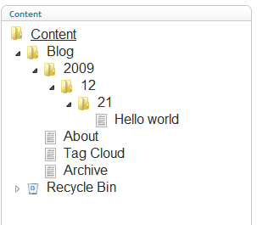Everything will be removable under the "installed packages" item.

After install is done, go to the content section. In the root of the website has been placed a "Blog" page. This contains all the pages installed by default.

Automatically, the blog creates a archive format based on Year, Month and day. Which ensures that all blog posts gets a nice url.

if you want to get started blogging, simply right click the Blog content page and select "publish" and then tell it to also publish   
all unpublished child nodes. Your blog is now public.

## Configuring your blog

To setup the name and description of your blog, click the "blog" page. It will open the configuration for this blog. Set the fields for "Blog name" and "Blog description". Then click "Save and publish" (the save icon with a globe next to it).

# Writing your first post

To create a new post, right click the Blog page, and select "Create". Choose the "Blog post" and click ok. An editor will be opened on the right hand side, and you can start writing content.

The editor is a standard "what you see is what you get" editor, and displays the content as it will look when published.

it supports media and formatting just like Microsoft Word.

## Adding images to a blog post

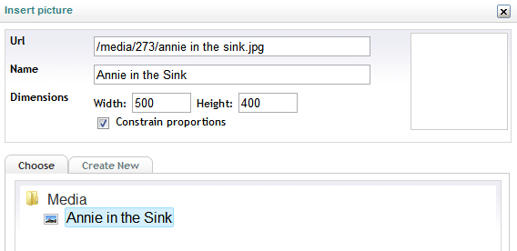To add an image to a post, click the  icon. This will open the umbraco media dialog, where you can pick items already in the media library or upload new content.

Umbraco automaticly scales the image down to a maximum of 500px when uploaded. It also resaves the image if you resize it in the editor. So you don't have to worry about very large images in your content.

## Tagging your content

All posts in Blog 4 umbraco can be "tagged" with a collection of keywords that describe what the content is about. So if you were publishing a blog post about Umbraco, you would most likely tag it "umbraco, cms, opensource, aps.net" for instance. This has 2 functions:

1. it shows what the post is about
2. It helps your readers find more content with the same subjects

To tag a page, enter keywords in the tag field, right below the editor

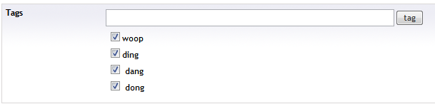

As you type it will suggest items, and if you seperate with a comma, it will devide the words into seperate tags when you hit enter.

# Change blog appearance

Blog 4 Umbraco supports using skins. So with a few mouse clicks you can change the way your blog looks. The amount of skins increases all the time as this is supported by the wonderful umbraco community.

To change the skin, go to the root of your blog in the umbraco Back-end, by default it will be named "Blog"

Open the page, and click the "Design" tab. Then click "Change theme"

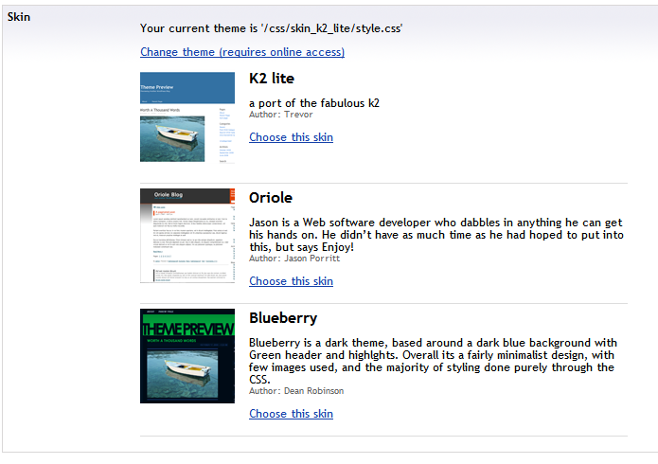A list of skins will be opened, with previews attached.

Click "choose this skin" to change the skin.

Umbraco will now download the needed files to your website.

Finally click "Save and publish" to make the blog change the skin.

## Edit the skin

The Skin which is actually a stylesheet. Is placed in the css folder in the "settings" section. So you can easily change the things you do not like about the chosen skin. Or use it as a base for a completely new skin

If you wish to change the blog visual appearance even more, you can start digging into the html in the templates or the code in the Xslts.

You can read more about editing those items in the skinning guide, which should be available the same place you downloaded this document.

# Configuring advanced features

## Configuring Akismet

[Akismet](http://akismet.com/) is a spam filtering service. It attempts to filter spam from blog comments . The filter works by combining information about spam captured on all participating blogs, and then using those spam rules to block future spam. The Akismet service is free for personal use. To use Akismet it is necessary to obtain a WordPress.com API key.

### Get your API key

You need to have a WordPress account to get an API Key, either [create an account at wordpress](http://wordpress.com/signup/) or log in using an existing account.

Once logged in look for the “My Account” button in the upper left and select Edit Profile.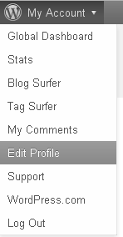  
At the top of your profile it should say “Your WordPress.com API key is: xxxxxxxxxx”. Copy that API key.

### Configure blog 4 umbraco

On the blog document you’ll find a ‘Spam settings’ tabpage where it’s possible to set the Akismet API Key, so just paste the API key in the textbox and save and publish the blog to configure and activate spam filtering on your comments.

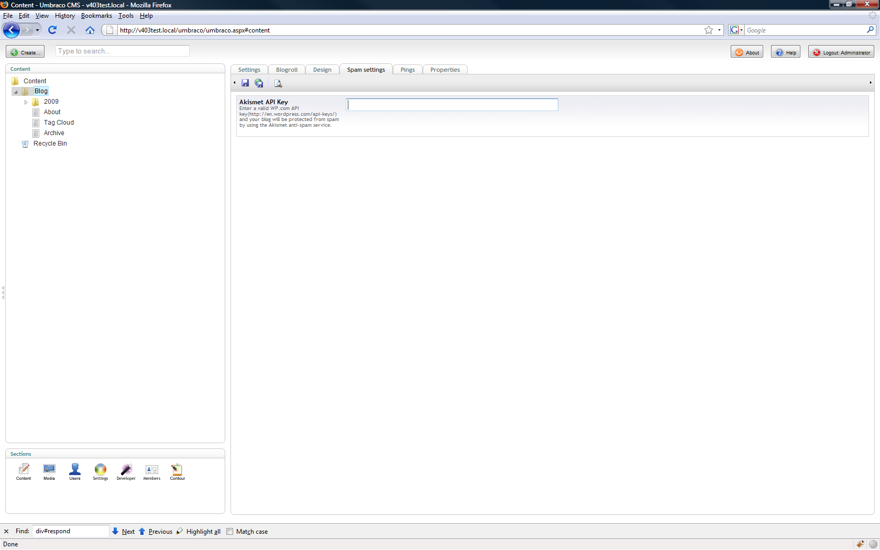

If the API Key is not set then the comment-spam filtering service won’t be activate.

## Setting up pinging

Pinging is for notifying search engines that you have added a new post, so that they can quickly index and list your content.

### Configure blog 4 umbraco

On the blog document you’ll find a ‘Pings’ tabpage where you can set the services you want to notify everytime a new blogpost get’s published.

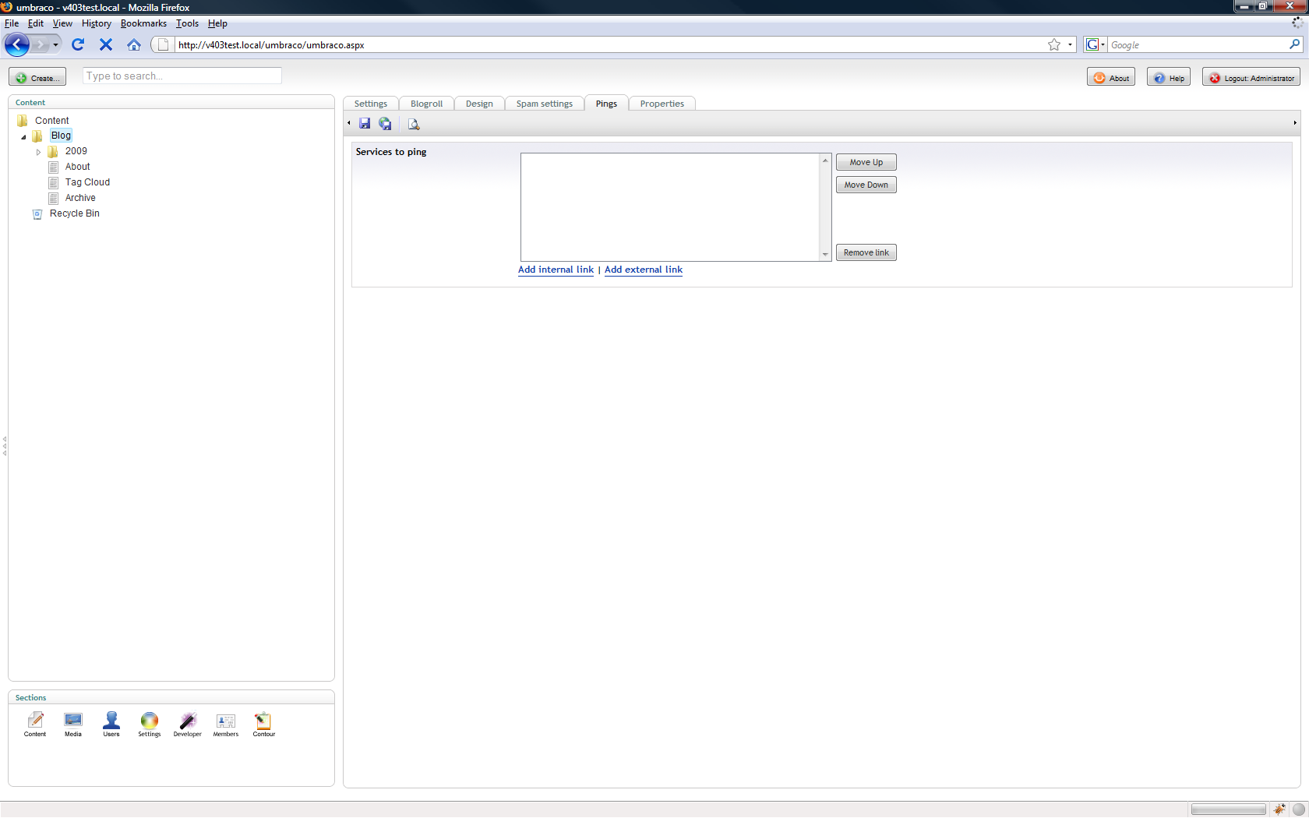

To add a new services just select ‘Add external link’, afterwards you’ll be able to set a Caption and the URL of this services.

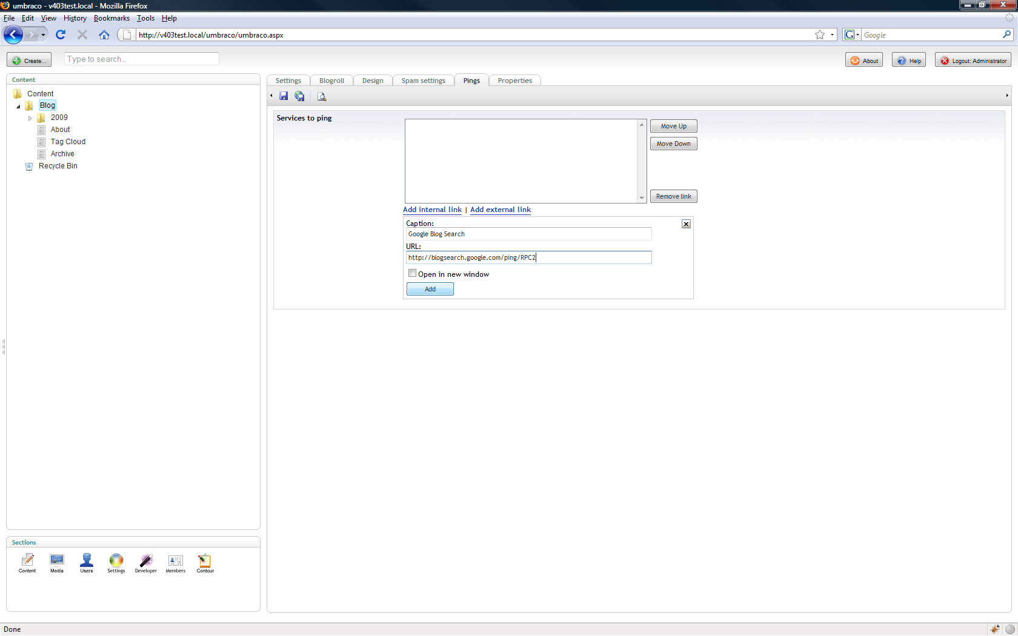

Once these 2 are set hit the Add button. Repeat this for each service you want to notify.

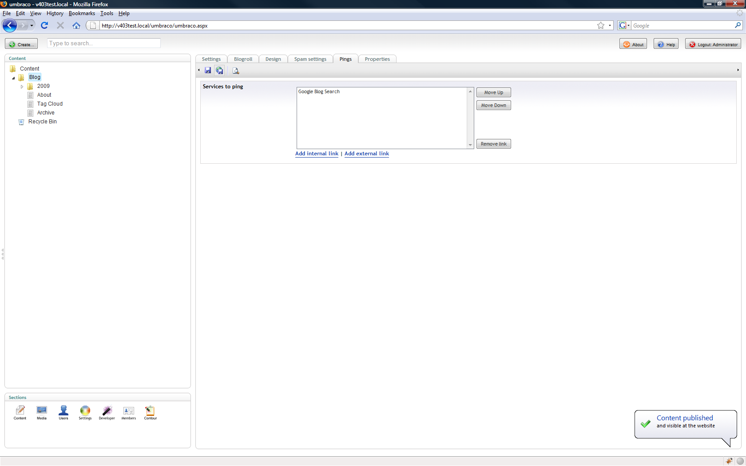

Once completed just save and publish the blog document to activate.

**Sample services to ping:**

* Ping-o-matic: http://rpc.pingomatic.com/
* Google blog search: http://blogsearch.google.com/ping/RPC2
* Technorati: http://rpc.technorati.com/rpc/ping
* weblogs.com: http://rpc.weblogs.com/RPC2

# Desktop blog publishing

Even though umbraco has a built-in, easy to use UI that runs in all browsers, sometimes it's just more convenient to use a desktop program to write your content.

You can access blog posts directly from your desktop, allowing you to edit and create new posts. You can even work off-line and upload when connected.

It’s possible to connect Microsoft Office Word 2007 or Windows Live Writer (which is free to download and use).

### Configuring the user

In order to make it possible for a user to setup desktop blog publishing you’ll have to setup a content channel, this can be done on the ‘Content Channel’ tab of the user (edit user in the user section). The content channel creation should be handled automatically by blog 4 umbraco. To make sure this is set you can just take a look at the content channel tab of the user.

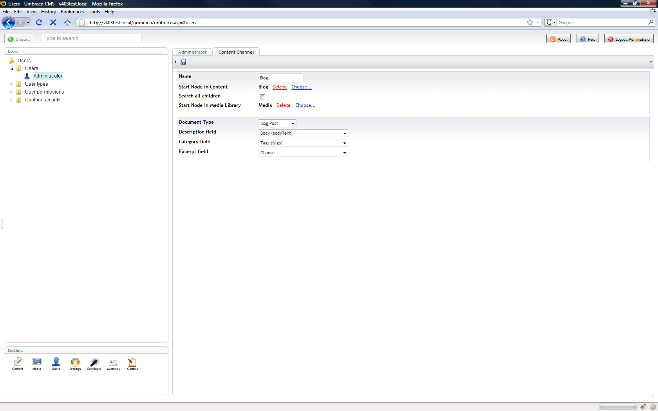

The document type should be set to ‘Blog Post’, the description field to ‘Body (bodyText)’ and the category field to ‘Tags (tags)’.

### Connecting Microsoft Office Word to the blog

Start Word and create a new Document

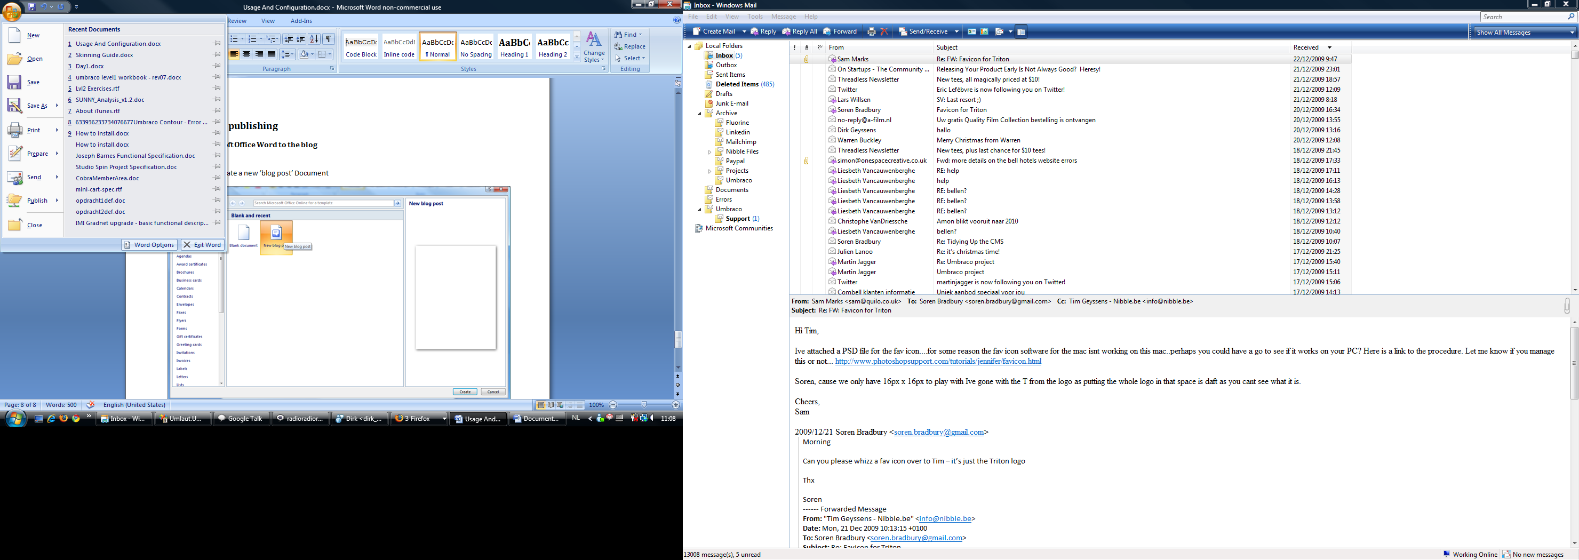

Choose the ‘New blog post’ template

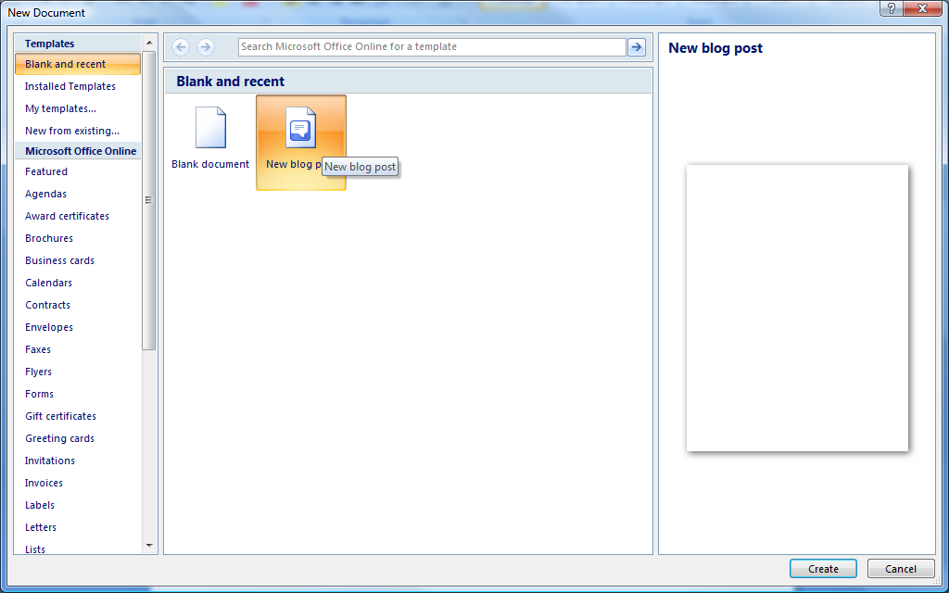

If this is the first time you create a new blog post you’ll be prompted to register a Blog Account. Choose ‘Register Now’



If there is already another account registered you’ll need to add a new account. So first select ‘Manage Accounts’ from the main menu



Then select ‘New’ in the Accounts dialog menu

z

The first step when adding a new blog account is to choose the blog provider in our case this is ‘Other’



The next and final step is to setup the Account



Choose ‘MetaWeblog’ in the API dropdown  
The Blog Post URL is the base url of your site followed by /umbraco/channels/word.aspx f.e. <http://www.mynewsite.com/umbraco/channels/word.aspx>  
The account information are the credentials you use to log into the umbraco backend.

Once the account info is set hit the ‘OK’ button. If the account settings are ok the registration will be successful.

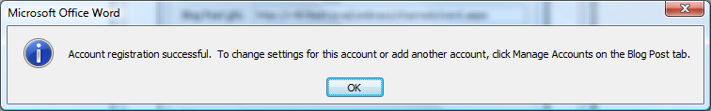

### Connecting Windows Live Writer to the blog

Windows Live Writer(WLW) is a free desktop application that makes it easier to compose compelling blog posts. It’s available for download here <http://download.live.com/writer>

Start WLW, From the toolbar, select Weblog>Add Weblog Account.

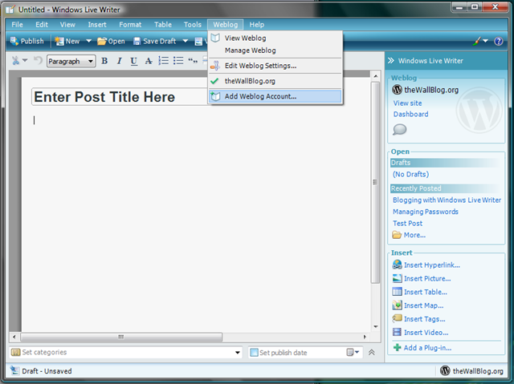

The Choose Weblog Type window displays. Select the **Another weblog service** button.

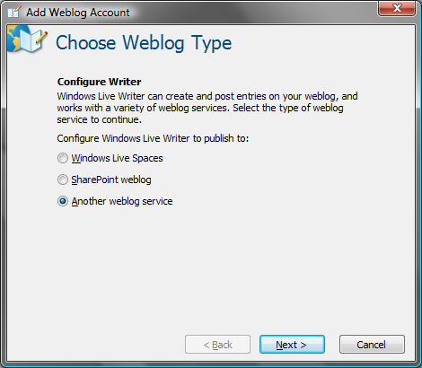

Click **Next>.** The Weblog Homepage and Login window opens.

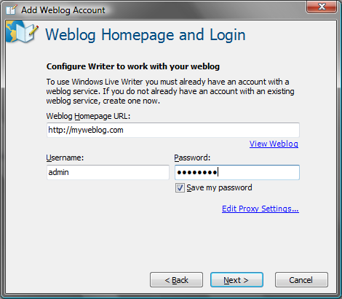

Enter your site information. The weblog homepage URL is the URL of the blog (f.ex. <http://www.mynewsite.com/blog.aspx>). The username and password are the same as the ones used to log into the umbraco backend.

Click **Next>.** WLW configures itself. WLW may ask if you want to import your sites template. This is optional. The Weblog Configuration Complete window displays.

Click Finish.